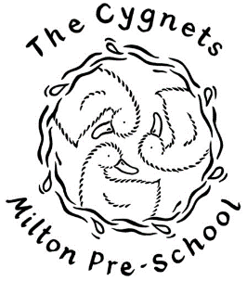
Things we should do at pre school
We should wash our hands with soap and water | 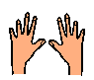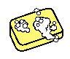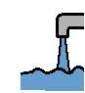
We should use tissues to catch our coughs and sneezes | 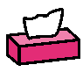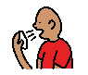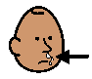
We should say goodbye to our grown up at the front door | 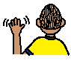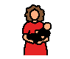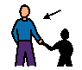
We should spend lots of time outside | 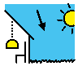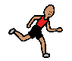
We should play with toys that we can keep clean | 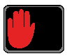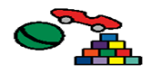
We should eat snack when there is room  Only three children at the table | 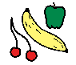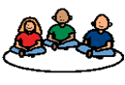
We will meet new Pre-School Practitioners | 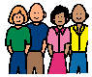
We will meet new friends | 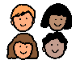
We should have lots of fun | 